Yuchen Duan (yuchend3)

IE598 MLF F18

Module 7 Homework (Random Forest)

Using the Wine dataset, described in Raschka chapter 4 and 10 fold cross validation;

**Part 1: Random forest estimators**

Fit a random forest model, try several different values for N_estimators, report in-sample accuracies.

1 2 4 10 21 46 100 215 464 1000

mean 1.0 0.944 1.0 1.0 1.0 0.933 1.0 1.0 1.0 1.0

std 1.0 0.944 1.0 1.0 1.0 0.933 1.0 1.0 1.0 1.0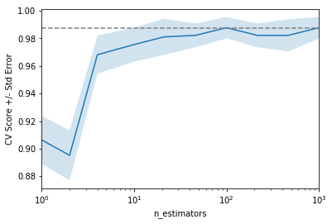

**Part 2: Random forest feature importance**

Display the individual feature importance of your best model in Part 1 above using the code presented in Chapter 4 on page 136. {importances=forest.feature_importances_ }

{'n_estimators': 100}

1) Flavanoids 0.166301

2) Proline 0.156037

3) Color intensity 0.148261

4) OD280/OD315 of diluted wines 0.131352

5) Alcohol 0.125929

6) Total phenols 0.058346

7) Hue 0.056940

8) Magnesium 0.037776

9) Alcalinity of ash 0.035967

10) Malic acid 0.035051

11) Proanthocyanins 0.018216

12) Ash 0.015427

13) Nonflavanoid phenols 0.014398

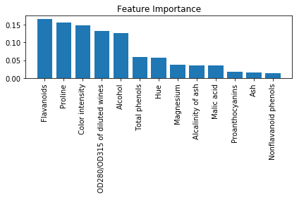

**Part 3: Conclusions**

Write a short paragraph summarizing your findings.

The higher the estimators better accuracy but the grow increase most between first 100. After 100 it even decrease a little but the run time has increase exponentially.

What is the optimal number of estimators for your forest?

My optimal number of estimators is 100 due to it’s run time and accuracy.

Favanoids have the most importance in my model each one time a ratio in computing the out put

**Part 4: Appendix**

Link to github repo

https://github.com/rainduan/IE598_F18_HW7